**LEMBAR OBSERVASI**

**Nomor RM :**

**Nama Lengkap :**

**Tanggal Lahir : L/P *)**

**EARLY WARNING SCORE (EWS)**

|  |  |  |  |  |  |  |  |  |  |  |  |  |  |  |  |  |  |  |  |  |  |
| --- | --- | --- | --- | --- | --- | --- | --- | --- | --- | --- | --- | --- | --- | --- | --- | --- | --- | --- | --- | --- | --- |
| **EWS** | | | | **Tanggal** | |  | | | | | | | |  | | | | | | | |
|  | | | |  | |  |  |  |  |  |  |  |  |  |  |  |  |  |  |  |  |
| **0** | **1** | **2** | **3** | **Jam** | |  |  |  |  |  |  |  |  |  |  |  |  |  |  |  |  |
|  | | | |  | |  |  |  |  |  |  |  |  |  |  |  |  |  |  |  |  |
| **TINGKAT KESADARAN** | | | | **Kesadaran** | |  |  |  |  |  |  |  |  |  |  |  |  |  |  |  |  |
| **GCS** | |  |  |  |  |  |  |  |  |  |  |  |  |  |  |  |  |
| **TEKANAN DARAH** | | | | | **S** |  |  |  |  |  |  |  |  |  |  |  |  |  |  |  |  |
| **D** |  |  |  |  |  |  |  |  |  |  |  |  |  |  |  |  |
| **NADI** | | | | **SUHU** | |  | | | | | | | |  | | | | | | | |
| **180**  **160** | | | | **42**  **41** | |  |  |  |  |  |  |  |  |  |  |  |  |  |  |  |  |
|  |  |  |  |  |  |  |  |  |  |  |  |  |  |  |  |
|  |  |  |  |  |  |  |  |  |  |  |  |  |  |  |  |
|  |  |  |  |  |  |  |  |  |  |  |  |  |  |  |  |
|  |  |  |  |  |  |  |  |  |  |  |  |  |  |  |  |
| **140** | | | | **40** | |  |  |  |  |  |  |  |  |  |  |  |  |  |  |  |  |
|  |  |  |  |  |  |  |  |  |  |  |  |  |  |  |  |
|  |  |  |  |  |  |  |  |  |  |  |  |  |  |  |  |
|  |  |  |  |  |  |  |  |  |  |  |  |  |  |  |  |
|  |  |  |  |  |  |  |  |  |  |  |  |  |  |  |  |
| **120** | | | | **39** | |  |  |  |  |  |  |  |  |  |  |  |  |  |  |  |  |
|  |  |  |  |  |  |  |  |  |  |  |  |  |  |  |  |
|  |  |  |  |  |  |  |  |  |  |  |  |  |  |  |  |
|  |  |  |  |  |  |  |  |  |  |  |  |  |  |  |  |
|  |  |  |  |  |  |  |  |  |  |  |  |  |  |  |  |
| **100** | | | | **38** | |  |  |  |  |  |  |  |  |  |  |  |  |  |  |  |  |
|  |  |  |  |  |  |  |  |  |  |  |  |  |  |  |  |
|  |  |  |  |  |  |  |  |  |  |  |  |  |  |  |  |
|  |  |  |  |  |  |  |  |  |  |  |  |  |  |  |  |
|  |  |  |  |  |  |  |  |  |  |  |  |  |  |  |  |
| **80** | | | | **37** | |  |  |  |  |  |  |  |  |  |  |  |  |  |  |  |  |
|  |  |  |  |  |  |  |  |  |  |  |  |  |  |  |  |
|  |  |  |  |  |  |  |  |  |  |  |  |  |  |  |  |
|  |  |  |  |  |  |  |  |  |  |  |  |  |  |  |  |
|  |  |  |  |  |  |  |  |  |  |  |  |  |  |  |  |
| **60** | | | | **36** | |  |  |  |  |  |  |  |  |  |  |  |  |  |  |  |  |
|  |  |  |  |  |  |  |  |  |  |  |  |  |  |  |  |
|  |  |  |  |  |  |  |  |  |  |  |  |  |  |  |  |
|  |  |  |  |  |  |  |  |  |  |  |  |  |  |  |  |
|  |  |  |  |  |  |  |  |  |  |  |  |  |  |  |  |
| **40** | | | | **35** | |  |  |  |  |  |  |  |  |  |  |  |  |  |  |  |  |
|  |  |  |  |  |  |  |  |  |  |  |  |  |  |  |  |
|  |  |  |  |  |  |  |  |  |  |  |  |  |  |  |  |
|  |  |  |  |  |  |  |  |  |  |  |  |  |  |  |  |
|  |  |  |  |  |  |  |  |  |  |  |  |  |  |  |  |
| **PERNAFASAN (x/m)** | | | | | |  |  |  |  |  |  |  |  |  |  |  |  |  |  |  |  |
| **SpO2 (%)** | | | | | |  |  |  |  |  |  |  |  |  |  |  |  |  |  |  |  |
| **OKSIGEN** | | | | **Ya/Tidak** | |  |  |  |  |  |  |  |  |  |  |  |  |  |  |  |  |
| **TOTAL Early Warning Score** | | | | | |  |  |  |  |  |  |  |  |  |  |  |  |  |  |  |  |
| **Kategori NEWSS** | | | | | |  |  |  |  |  |  |  |  |  |  |  |  |  |  |  |  |
| **Kategori PEWSS** | | | | | |  |  |  |  |  |  |  |  |  |  |  |  |  |  |  |  |
| **Skala Jatuh** | | | | | |  |  |  |  |  |  |  |  |  |  |  |  |  |  |  |  |
| **Skala Nyeri** | | | | | |  |  |  |  |  |  |  |  |  |  |  |  |  |  |  |  |
| **Intake** | | | | | |  |  |  |  |  |  |  |  |  |  |  |  |  |  |  |  |
| **Output** | | | | | |  |  |  |  |  |  |  |  |  |  |  |  |  |  |  |  |
| **Diit** | | | | | |  |  |  |  |  |  |  |  |  |  |  |  |  |  |  |  |
| **Nama Petugas** | | | | | |  |  |  |  |  |  |  |  |  |  |  |  |  |  |  |  |
| **Paraf** | | | | | |  |  |  |  |  |  |  |  |  |  |  |  |  |  |  |  |

*Kategori EWS : - Hijau (Pasien dalam keadaan stabil) - Orange (Pengkajian tiap jam, lapor dr. jaga ruangan)*

* *Kuning (Lapor Pj. Shift, pengkajian ulang tiap 2 jam) - Merah (aktifkan Code Blue, lapor dr. Jaga ruangan dan DPJP)*

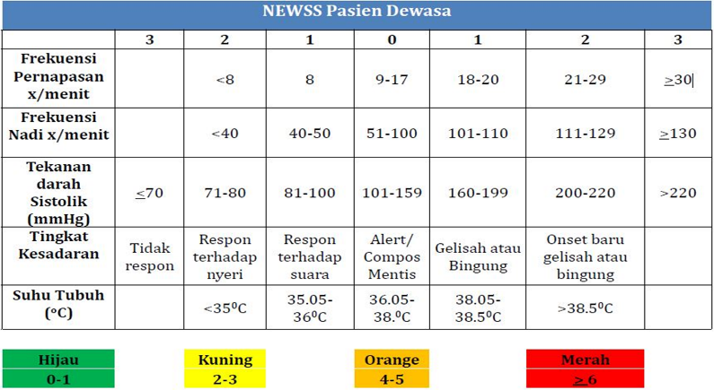 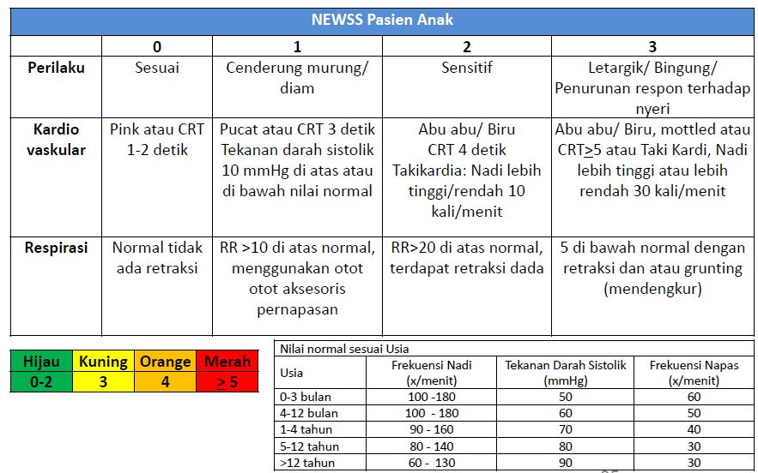

RM 14.3/K-EWS/RSDM/2018